**Top Accounting Scandals**

**A recap of the top scandals in the past**

Written by [**CFI Team**](https://corporatefinanceinstitute.com/about-cfi/)

Updated November 26, 2022

**Accounting Scandals – List and Overview**

The last two decades saw some of the worst accounting scandals in history. Billions of dollars were lost as a result of these [financial disasters](https://www.britannica.com/topic/Financial-Crisis-of-2008-The-1484264), which destroyed companies and ruined peoples’ lives. Many of these accounting scandals were a result of the excessive greed of a few individuals whose actions led to disastrous consequences which brought down whole companies and affected millions of people. In this article, we look at the 10 biggest accounting scandals in recent times.

**Top 10 Accounting Scandals in the Past Decades**

**Waste Management Scandal (1998)**

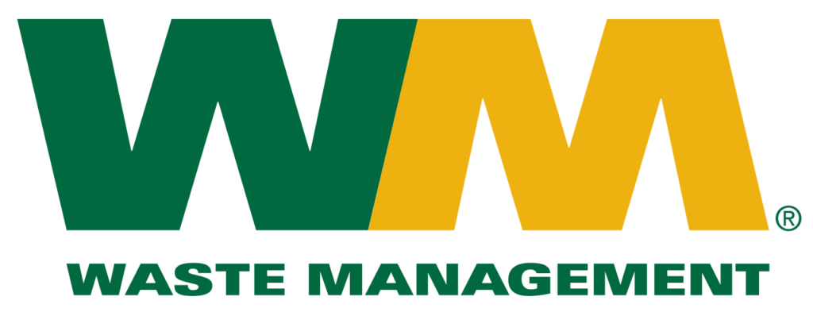

Waste Management Inc. is a publicly-traded US waste management company. In 1998, the company’s new CEO, A Maurice Meyers, and his management team discovered that the company had reported over $1.7 billion in fake earnings.

The [Securities and Exchange Commission](https://corporatefinanceinstitute.com/resources/data/public-filings/types-of-sec-filings/)(SEC) found the company’s owner and former CEO, Dean L Buntrock, guilty, along with several other top executives. In addition, the SEC fined Waste Management’s auditors, Arthur Andersen, over $7 million. Waste Management eventually settled a shareholder class-action suit for $457 million.

**Enron Scandal (2001)**

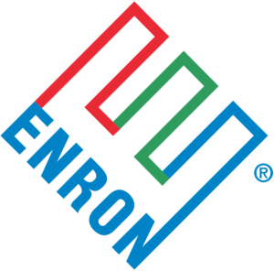

Enron Corporation was a US energy, commodities, and services company based out of Houston, Texas. In one of the most controversial accounting scandals in the past decade, it was discovered in 2001 that the company had been using accounting loopholes to hide billions of dollars of bad debt, while simultaneously inflating the company’s [earnings](https://corporatefinanceinstitute.com/resources/knowledge/accounting/retained-earnings-guide/). The scandal resulted in shareholders losing over $74 billion as Enron’s share price collapsed from around $90 to under $1 within a year.

An SEC investigation revealed that the company’s CEO, Jeff Skillings, and former CEO, Ken Lay, had kept billions of dollars of debt off the company’s balance sheet. In addition, they had pressured the company’s auditing firm, Arthur Andersen, to ignore the issue.

The two were convicted, largely based on the testimony of former Enron employee, Sherron Watkins. However, Lay died before serving time in prison. Jeff Skillings was sentenced to 24 years in prison. The scandal led to the bankruptcy of Enron and dissolution of Arthur Andersen.

After the fact, the convictions were as controversial as the company’s collapse had been shocking, as prosecutor Andrew Weissman indicted not just individuals, but the entire accounting firm of Arthur Andersen, effectively putting the company out of business. It was little consolation to the 20,000 employees who had lost their jobs when the conviction was later overturned.

**WorldCom Scandal (2002)**



WorldCom was an American telecommunications company based out of Ashburn, Virginia. In 2002, just a year after the Enron scandal, it was discovered that WorldCom had inflated its assets by almost $11 billion, making it by far one of the largest accounting scandals ever.

The company had underreported line costs by capitalizing instead of expensing them and had inflated its revenues by making false entries. The scandal first came to light when the company’s internal audit department found almost $3.8 billion in fraudulent accounts. The company’s CEO, Bernie Ebbers, was sentenced to 25 years in prison for fraud, conspiracy, and filing false documents. The scandal resulted in over 30,000 job losses and over $180 billion in losses by investors.

**Tyco Scandal (2002)**

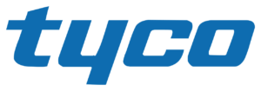

Tyco International was an American blue-chip security systems company based out of Princeton, New Jersey. In 2002, it was discovered that CEO, Dennis Kozlowski, and CFO, Mark Swartz, had stolen over $150 million from the company and had inflated the company’s earnings by over $500 million in their reports. Kozlowski and Swartz had siphoned off money using unapproved loans and stock sales.

The scandal was discovered when the SEC and the office of the District Attorney of Manhattan carried out investigations related to certain questionable accounting practices by the company. Kozlowski and Swartz were both sentenced to 8 to 25 years in prison. A class-action suit forced them to pay $2.92 billion to investors.

**HealthSouth Scandal (2003)**

Accounting Scandals - HealthSouth Corporation

HealthSouth Corporation is a top US publicly traded healthcare company based out of Birmingham, Alabama. In 2003, it was discovered that the company had inflated earnings by over $1.8 billion. The SEC had previously been investigating HealthSouth’s CEO, Richard Scrushy, after he sold $75 million in stock a day before the company posted a huge loss. Although charged, Scrushy was acquitted of all 36 counts of accounting fraud. However, he was found guilty of bribing then Alabama Governor, Don Siegelman, and was sentenced to seven years in prison.

**Freddie Mac Scandal (2003)**



The Federal Home Loan Mortgage Corporation, also known as Freddie Mac, is a US federally-backed mortgage financing giant based out of Fairfax County, Virginia. In 2003, it was discovered that Freddie Mac had misstated over $5 billion in earnings. COO David Glenn, CEO Leland Brendsel, former CFO Vaughn Clarke, and former Senior Vice Presidents Robert Dean and Nazir Dossani had intentionally overstated earnings in the company’s books. The scandal came to light due to an SEC investigation into Freddie Mac’s accounting practices. Glenn, Clarke, and Brendsel were all fired and the company was fined $125 million.

**American International Group (AIG) Scandal (2005)**

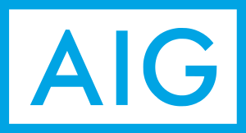

American International Group (AIG) is a US multinational insurance firm with over 88 million customers across 130 countries. In 2005, CEO Hank Greenberg was found guilty of stock price manipulation. The SEC’s investigation into Greenberg revealed a massive accounting fraud of almost $4 billion.

It was found that the company had booked loans as revenue in its books and forced clients to use insurers with whom the company had pre-existing payoff agreements. The company had also asked stock traders to inflate the company’s share price. AIG was forced to pay a $1.64 billion fine to the SEC. The company also paid $115 million to a pension fund in Louisiana and $725 million to three pension funds in Ohio.

**Lehman Brothers Scandal (2008)**

Accounting Scandals - Lehman Brothers

Lehman Brothers was a global financial services firm based out of New York City, New York. It was one of the largest investment banks in the United States. During the 2008 financial crisis, it was discovered that the company had hidden over $50 billion in loans. These loans had been disguised as sales using accounting loopholes.

According to an SEC investigation, the company had sold toxic assets to banks in the Cayman Islands on a short-term basis. It was understood that Lehman Brothers would buy back these assets. This gave the impression that the company had $50 billion more in cash and $50 billion less in toxic assets. In the aftermath of the scandal, Lehman Brothers went bankrupt.

**Bernie Madoff Scandal (2008)**

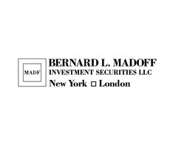

Bernie Madoff is a former American stockbroker who orchestrated the**biggest Ponzi scheme in history**, and also one of the largest accounting scandals. Madoff ran Bernard L. Madoff Investment Securities LLC. After the 2008 financial crisis, it was discovered that Madoff had tricked investors out of over $64.8 billion.

Madoff, his accountant, David Friehling, and second in command, Frank DiPascalli, were all convicted of the charges filed against them. The former stockbroker received a prison sentence of 150 years and was also ordered to pay $170 billion in restitution.

**Satyam Scandal (2009)**



Satyam Computer Services was an Indian IT services and back-office accounting firm based out of Hyderabad, India. In 2009, it was discovered that the company had inflated revenue by $1.5 billion, marking one of the largest accounting scandals.

An investigation by India’s Central Bureau of Investigation revealed that Founder and Chairman, Ramalinga Raju, had falsified revenues, margins, and cash balances. During the investigation, Raju admitted to the fraud in a letter to the company’s board of directors. Although Raju and his brother were charged with breach of trust, conspiracy, fraud, and falsification of records, they were released when the Central Bureau of Investigation failed to file charges on time.